Exercises
2.2.1 Introduction to Connection Tables
1. Number each of the atoms in the structural formula for benzoic acid in SCT XI.
2. Write two different valid SCTs for each of structures a) - c).
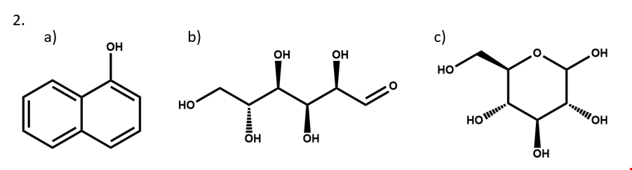
3. Draw structural formulas for the compounds represented by SCTs a) – c).
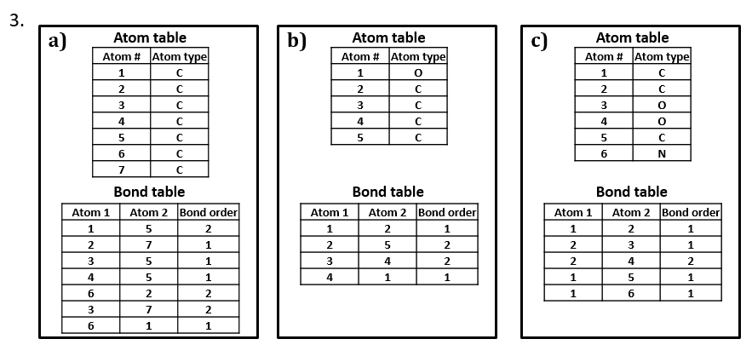
4. Write a chemically-equivalent structural formula for 2a) that results in a non-equivalent SCT. Then, write that SCT.

2.2.2 Anatomy of a MOL file

1. Does Hack-A-Mol handle the number 4 for an aromatic bond? How can you tell? Can you create a chemically sound but non-aromatic structure using 4s in the bond field?

2. Perfluorinated octanoic acid (PFOA) is a surfactant that played a key role for a long time in the manufacture of fluorinated polymers including Teflon. Over the past decade, it has been the subject of significant public health concern and a whole bunch of litigation.
Pull PFOA into Hack-a-Mol by typing it into the text search box below the 3D window and clicking “search.”
2a. Edit the mole file to defluorinate PFOA, converting it into octanoic acid.
2b. Now make it into acetic acid. (It is possible to do this in a way that yields correct-looking 2D and 3D renderings without changing any XYZ coordinately, but you have to be ***very*** careful about how you delete and relabel atoms and bonds.)

