EXERCISES
1. Using PubChem’s tool for compound search (go here and click the hexagon to search by structural formula), or other programs of your choice (SciFinder, ChemSpider, Wikipedia (if you dare)), fill in the following table. (For more information, see Exchanging Chemical Representations, above. For more on SMILES and InChI, see the third part of this module.)
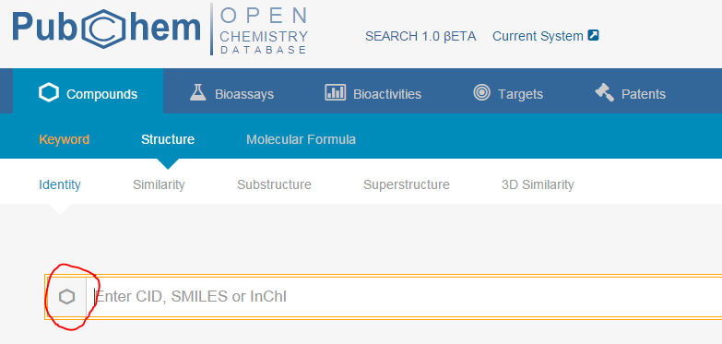
molecular formula | Structural formula | Systematic name | SMILES | InChI | CAS RN
 |  |  | CC(=C)C=C
 |  | Ammonium acetate
C₆H₆O
 |  |  |  |  | 105-53-3

2. Many chemistry databases index by structural formulas based on explicit connectivity for organic small molecules. Many molecules do not fit easily into these conventions for representing bonds, such as coordination compounds and delocalized systems. (Conventions for human-readable and computer-readable graphical representation of such compounds are discussed above.) Of the representations below for a coordination substructure, which is most likely to be acceptable for publication? Which for searching an index? How might each of these representation be interpreted in a database?
I II III

3. Resolve each of the following the systematic names listed for Vitamin C into structural formulae using each of the systems below. Is the expected stereochemistry represented? (For more information, see Formulating Chemical Structure Data, above.)
openmolecules: http://www.openmolecules.org/name2structure
OPSIN: http://opsin.ch.cam.ac.uk/
CACTUS: http://cactus.nci.nih.gov/chemical/structure
ChemSpider: http://www.chemspider.com/
PubChem: https://pubchem.ncbi.nlm.nih.gov/
- (R)-3,4-dihydroxy-5-((S)-1,2-dihydroxyethyl)furan-2(5H)-one
- (R)-5-((S)-1,2-dihydroxyethyl)-3,4-dihydroxyfuran-2(5H)-one
- (2R)-2-[(1S)-1,2-dihydroxyethyl]-3,4-dihydroxy-2H-furan-5-one
- (5R)-[(1S)-1,2-dihydroxyethyl]-3,4-dihydroxy-3-oxolen-2-one

